# **Name: Abdurrahman Qureshi**

# **Roll No: 210451**

Practical No: 4

**1) Write a program to create a string using different methods and finding the length of string.**

**CODE:**

let str1 = "Spectre";

let str2 = "Reaper";

let str3 = String("Firebreak");

let a = ["Sparrow", "Nomad"];

let str4 = a[0] + a[1];

let str5 = String.fromCharCode(112, 114, 111, 112, 104, 101, 116);

console.log("Different ways to create Strings:\n");

console.log(

str1 + '\t\t--- let str1 = "Spectre";\t\t\t\t\t\t\t\t' + "String Length : " + str1.length,);

console.log(str2 + '\t\t--- let str2 = "Reaper";\t\t\t\t\t\t\t\t' + "String Length : " + str2.length,);

console.log(str3 +

'\t--- let str3 = String("Firebreak");\t\t\t\t\t\t\t' +"String Length : " str3.length,);

console.log(str4 +

'\t--- let a = ["Sparrow", "Nomad"];+ "let str4 = a[0] + a[1];"\t\t\t\t' +

"String Length : " +

str4.length,);

console.log(str5 +

"\t\t--- let str5 = String.fromCharCode(112, 114, 111, 112, 104, 101, 116);\t\t\t" +

"String Length : " +

str5.length,);

**OUTPUT:**

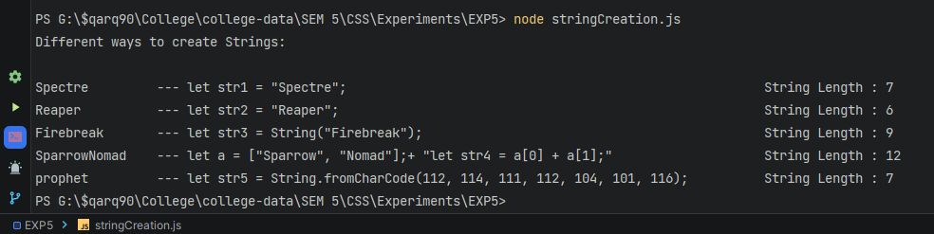

**2) Write a program to find the index of particular String using different parameters.**

**CODE:**

let myString = "54";

function stringToNum(str) {

return Number(str); }

function stringToInt(str) {

return parseInt(str); }

function stringToFloat(str) {

return parseFloat(str); }

let myNum = stringToNum(myString);

let myFloat = stringToFloat(myString);

let myInt = stringToInt(myString);

process.stdout.write("Original String : " + myString + "\n\n");

process.stdout.write("String to Integer : " + '"' + myInt + '"' + "\n");

process.stdout.write("String to Number : " + '"' + myNum + '"' + "\n");

process.stdout.write("String to Float : " + '"' + myFloat + '"' + "\n");

**OUTPUT:**

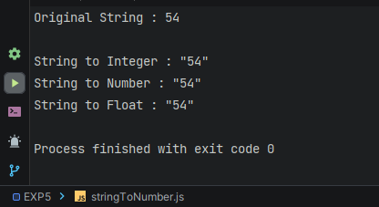

**3) Write a program to concatenate two strings.**

**CODE:**

let str1 = "Spectre";

let str2 = "Ripper";

let str3 = str1 + str2;

let str4 = str1.concat(str2);

process.stdout.write("str1 = " + str1 + "\n");

process.stdout.write("str2 = " + str2 + "\n");

process.stdout.write("str1.concat(str2) = " + str3 + "\n");

process.stdout.write("str1 + str2 = " + str4);

**OUTPUT:**

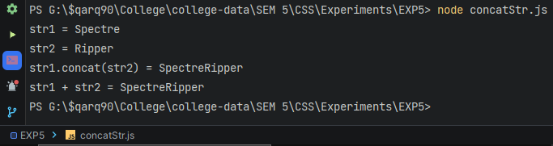

**4) Write a program for replacing and converting the String to uppercase and Lowercase using different methods and parameters.**

**CODE:**

const stringChanges = (ogStr, need, replacer) => {

let newStr = ogStr.replace(need, replacer);

let toUpper = ogStr.toUpperCase();

let toLower = ogStr.toLowerCase();

process.stdout.write("Original : \t\t" + ogStr + "\n");process.stdout.write("After Replacement : \t" + newStr + "\n");

process.stdout.write("UpperCased : \t\t" + toUpper + "\n");

process.stdout.write("LowerCased : \t\t" + toLower + "\n");};

let myString = "Jesse, we need to cook";

let nameStr = "Jesse";

let changeName = "Yo Mr. White";

stringChanges(myString, nameStr, changeName);

**OUTPUT:**

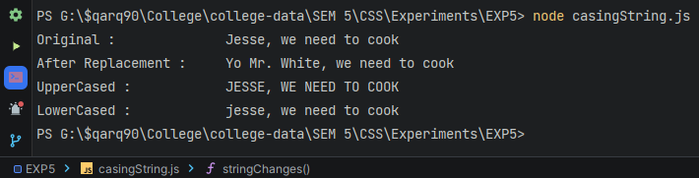

**5) Write a program for extracting the String using different parameters.**

**CODE:**

const extractString = (ogStr,sInd,lInd) => {

const subString = ogStr.substring(sInd,lInd);

const sliceString = ogStr.slice(sInd,lInd);

process.stdout.write("Original String : " + ogStr + "\n");

process.stdout.write("Sub-String : " + subString + "\n");

process.stdout.write("Slice-String : " + sliceString + "\n");}

let myString = "My name is Gustavo Fring but you can call me Gus.";

let sIndex = 10;

let lIndex = 35;

extractString(myString,sIndex,lIndex);

**OUTPUT:**

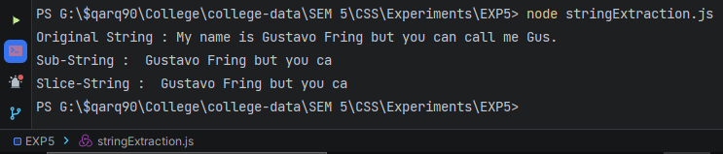

**6) Write a program to find the index of particular String using different parameters.**

**CODE:**

const indexString = (ogStr,s1,s2,s3) => {

let str1 = ogStr.indexOf(s1);

let str2 = ogStr.indexOf(s2);

let str3 = ogStr.indexOf(s3);

process.stdout.write("Original String : \t\t" + ogStr + "\n");

process.stdout.write("String A = 'ONE' : \t\t" + str1 + "\n");

process.stdout.write("String B = 'who' : \t\t" + str2 + "\n");

process.stdout.write("String C = 'knocks' :\t\t" + str3 + "\n");

};

let myString = "I am the ONE who knocks";

let str1 = "ONE";

let str2 = "who";

let str3 = "knocks";

indexString(myString, str1, str2, str3);

**OUTPUT:**

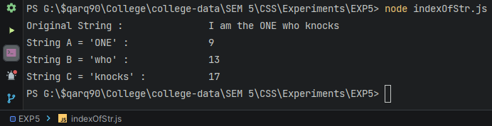

**7) Write a program to trim the whitespace, find the character code as well as the character at the specific index**

**CODE:**

let myString =

" Next to nothing is known about the presumed wet-works Specialist, Spectre. ";

let myIndex = 66;

let charCodestr = myString.charCodeAt(myIndex);

let charAtstr = myString.charAt(myIndex);

let whiteLess = myString.trim();

console.log("Original String : " + myString);

console.log("White Space Less : " + whiteLess);

console.log("charCodeAt : " + charCodestr);

console.log("charAt : " + charAtstr);

**OUTPUT:**

